St Peter's Christmas Newsletter 2019


MONDAY 2nd DECEMBER  Fun begins with mufti day Monday 2 December! Children are asked to bring a tombola prize in return for wearing “home” clothes.   | FRIDAY 6th DECEMBER 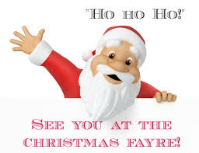  Christmas Fayre  Fayre begins at 4 pm on with a visit from Father Christmas –our fayre will end in spectacular fashion with a firework display! Entry to the fayre is £3 per adult, children may join us free of charge but must be accompanied by an adult | 10/11/12 DECEMBER  9.30am  EYFS/ KS1 Nativity  Our youngest pupils will put us all in the Christmas spirit with “Shepherd’s Delight”  We ask that:  Reception Parents join us on 10th December, Year 1 parents on 11th December  Year 2 parents on 12th December.   | FRIDAY 13th DECEMBER  National Christmas Jumper Day    In order to support Save the Children on National Christmas jumper day-the children may come to school in their Christmas jumpers again! They do not have to wear school uniform and may bring in a donation for Save the Children if they wish.
TUESDAY 17th DECEMBER    Carol Service  - Children will need to wear their school uniform for our Church service which begins at 9.30am- all are welcome to join us. | WEDNESDAY 18th DECEMBER  The Prince and the Pauper -Theatre Trip    All pupils to be in school uniform- Children will need a packed lunch. They will also need water bottles to take to the theatre, snacks will be provided by school. | THURSDAY 19th DECEMBER  Christmas Lunch & Celebration  Children are invited to come to school in party clothes are welcome to wear Christmas hats! The children will enjoy a “Party Day” with Christmas Lunch and a games afternoon.   | FRIDAY 20th DECEMBER  PD DAY  School closed until 6th January 2020  

